**REAL TIME STOCK PRICE PREDICTION**

**ABSTRACT**

The stock market is characterized by its inherent volatility and unpredictability, presenting a formidable challenge for researchers and investors alike. For decades, the application of time-series analysis to forecast future stock prices has garnered significant attention, yet it remains one of the most complex and potentially rewarding endeavors in financial analytics. Stock price movements are influenced by a multitude of factors, many of which are difficult to quantify. Key variables include historical stock data, trading volumes, and current market prices, alongside fundamental elements like a company’s intrinsic value, asset composition, quarterly earnings, and strategic initiatives. While some of these factors can be integrated into mathematical models, the complexity of the market dynamics often limits the effectiveness of such predictions. Additionally, unforeseen events—such as geopolitical crises or global pandemics—can dramatically alter market conditions in ways that are impossible to forecast. This paper explores the challenges of real-time stock price prediction using machine learning techniques, highlighting both the potential benefits and the limitations inherent in modeling such a complex system. By examining various machine learning approaches and their effectiveness in navigating the unpredictability of the stock market, this research aims to contribute to the ongoing discourse on enhancing predictive accuracy in financial markets.

**INTRODUCTION**

Stock price prediction using machine learning is a complex process that involves forecasting the future value of a stock traded on a stock exchange. The primary goal of stock price prediction is to reap profits by making informed investment decisions. However, predicting stock prices with high accuracy is a challenging task due to the involvement of multiple factors.

These factors can be broadly categorized into two types: internal and external. Internal factors include the company's financial performance, management team, and industry trends. External factors, on the other hand, include economic indicators, geopolitical events, and market sentiment. The interplay between these factors makes it difficult to predict stock prices with certainty.

Machine learning plays a vital role in stock price prediction by analyzing historical data and identifying patterns and trends. Machine learning algorithms can process large amounts of data quickly and accurately, making them ideal for stock price prediction. These algorithms can be trained on historical data to learn the relationships between various factors and stock prices.

Some common machine learning algorithms used for stock price prediction include linear regression, decision trees, and neural networks. These algorithms can be used to predict stock prices based on various inputs, such as historical stock prices, trading volumes, andeconomic indicators.

While machine learning can improve the accuracy of stock price prediction, it is not a foolproof method. There are several limitations and challenges associated with machine learning-based stock price prediction. For example, machine learning algorithms can be biased towards historical data and may not be able to capture sudden changes in market trends.

Therefore, it is essential to use machine learning in conjunction with other methods, such as fundamental analysis and technical analysis, to make informed investment decisions. By combining machine learning with other methods, investors can gain a more comprehensive understanding of the stock market and make more accurate predictions.

**Stock Price as a Time Series Data**

When treating stock data as a time series, historical stock prices and other relevant parameters can be leveraged to forecast future stock prices. This approach enables the prediction of stock prices for the next day or week, providing valuable insights for investors. In the realm of machine learning, models such as Recurrent Neural Networks (RNNs) and Long Short-Term Memory (LSTMs) networks have gained popularity for predicting time-series data, including stock prices.

These models are particularly effective in analyzing sequential data, where the order of events matters. By examining past stock prices and other market features, RNNs and LSTMs can identify patterns and trends that inform future price predictions. The key idea is to strike a balance between the importance of recent and older data, determining which parameters have the most significant impact on current or future stock prices.

In this context, the machine learning model assigns weights to each market feature, effectively determining the relative importance of each factor in predicting stock prices. Furthermore, the model can assess how much historical data is necessary to make accurate predictions, ensuring that the most relevant information is considered**.**

**Stock Price Prediction using Moving Average Time Series**

To start, we can utilize moving averages (MA) to analyze how the length of historical data—specifically, the number of past data points—impacts the performance of our prediction model. A simple moving average calculates the average of the previous N data points and uses this average as the forecast for the next value (N+1). This technique helps to smooth out fluctuations in the data and provides a clearer view of the underlying trends.

Moving averages are a fundamental tool in time-series analysis, allowing us to assess the influence of different periods of historical data on future predictions. By adjusting the value of N, we can observe how varying the amount of past data affects the accuracy of our predictions. This approach lays the groundwork for more sophisticated forecasting methods, as it highlights the importance of historical context in stock price prediction.

So,

Stock Price Prediction using Moving Average Time Series 

In our analysis, let P1 to Pn represent the n most recent data points leading up to the present. To predict the current data point, we calculate the Simple Moving Average (SMA) based on the size n, meaning we consider up to n data points from the past. The SMA serves as our predicted value. The accuracy of this model is highly influenced by the choice of n. A larger n indicates a willingness to incorporate more historical data into the calculation of the present value. For instance, if n=2, we average the stock prices from the previous two days, while n=50 would involve a 50-day average. Naturally, using 50 days of data provides a richer context for identifying stock trends, potentially leading to more accurate predictions. However, it's essential to consider that a larger n can also destabilize the model, as it may smooth out critical short-term fluctuations. For example, analyzing data from the past 300 days might be excessive and counterproductive.

Another approach to moving averages is the Exponential Moving Average (EMA), which assigns greater weight to more recent data points. This method allows us to consider a broader range of historical data while still maintaining sensitivity to recent trends and fluctuations. By emphasizing recent samples, the EMA can provide a more responsive measure of stock price movements, making it particularly useful in fast-changing market conditions.

exponential moving average

In this context, let Pt represent the price at time t, and k denote the weight assigned to that particular data point. The value EMA(t-1) refers to the Exponential Moving Average calculated from the previous t-1 data points. It is evident that the Exponential Moving Average (EMA) generally outperforms the Simple Moving Average (SMA) in terms of predictive accuracy. The weight k is determined using the formula ( k = \frac{2}{N + 1} ), where N is the number of periods considered.

As we implement these methods, we will observe that the EMA tends to yield better results than the SMA. This is due to the EMA's ability to assign greater importance to more recent data points, which can lead to more accurate forecasting. For the purposes of this analysis, we will assume that this trend holds true for stock prices treated as time series data.

By incorporating a larger amount of historical data and placing more emphasis on the latest observations, the EMA indeed demonstrates superior performance compared to the SMA. However, it is important to note that the static nature of the parameters in the EMA can limit its effectiveness across different scenarios. In the EMA, the weight k (which indicates the significance of past data) is fixed and closely tied to the window size N (the extent of historical data considered).

Manually setting these parameters can be challenging, and optimizing them for a stock market prediction project using machine learning may not be feasible. Therefore, we can explore more advanced models capable of dynamically adjusting the significance of each past data point, enhancing the accuracy of our predictions. One such model that comes to mind is the Long Short-Term Memory (LSTM) network, which is well-suited for this type of time-series forecasting.

**Understanding Long Short Term Memory Network for Stock Price Prediction**

Long Short-Term Memory (LSTM) is a type of Recurrent Neural Network (RNN) designed for processing sequential data. It learns to retain important information from a time window while discarding irrelevant details. Thenetwork maintains a "memory" that is continuously updated with each timestep, determining the significance of newinformation. Over time, LSTM has transformed various fields, including speech and handwriting recognition, language comprehension, and forecasting, becoming integral to modern applications.

An LSTM cell is composed of three main gates: the input gate, output gate, and forget gate. These gates adjust their weights to control how much of the current input is retained and how much of the previous information isdiscarded. This structure is a significant enhancement over earlier RNN models, addressing some of their limitations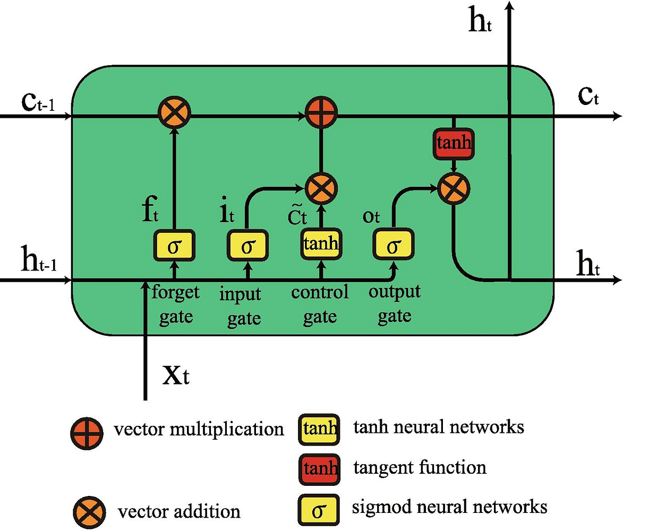

In the equations below, iii, fff, and ooo represent the input, forget, and output gates, respectively. The cell state, denoted by CCC, stores the learned information, while the output is represented by hhh. These calculations are performed at each timestep ttt, taking into account the data learned from the previous timestep (t−1)(t-1)(t−1).

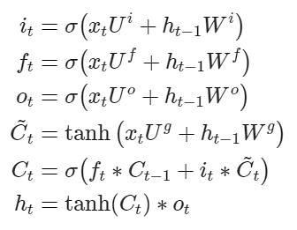

The forget gate determines which information and how much of it should be removed from the current cell state, while the input gate decides what new information will be added. The output gate, involved in the final equation, controls the scale of the output based on the operations of the previous gates.

Unlike traditional feed-forward neural networks, LSTMs have the ability to actively retain or discard parts of past data sequences. Their ability to process and learn from sequential windows of data makes their training distinct. Let's implement the model in Python.

**Assessing the Performance of Stock Price Prediction Models**

Before implementing the algorithms, it's essential to define the metric that will be used to evaluate the performance of our models. Since stock price prediction is fundamentally a regression task, suitable metrics include RMSE (Root Mean Squared Error) and MAPE (Mean Absolute Percentage Error), which assess the accuracy of our predictions in comparison to actual stock prices.

Examining the RMSE formula, it becomes clear that this metric calculates the discrepancy (or error) between actual prices (AtA_tAt​) and predicted prices (FtF_tFt​) over all NNN timestamps, providing a quantitative measure of the average error magnitude.

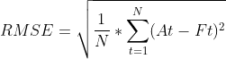

Conversely, MAPE (Mean Absolute Percentage Error) evaluates the error relative to the true value, indicating how far the predicted prices deviate in percentage terms rather than absolute differences. This metric is particularly useful for managing error consistency across varying scales, which is essential when working with data that spans large or small values. For example, while RMSE for figures in the range of 10610^6106 could produce disproportionately large error values, MAPE maintains the error within a controlled range, offering a more balanced perspective.

MAPE

**LITERATURE REVIEW**

Stock price prediction has garnered significant research interest in finance due to its critical role in investment and risk management. Leveraging machine learning (ML) and data science approaches has enabled more accurate forecasting of stock trends, which conventional models often struggle to achieve due to market volatility and complex non-linear behavior. This review highlights various ML methodologies applied to stock price prediction and discusses their integration with data science strategies.

**Deep Learning Models in Stock Market Forecasting** The application of deep learning models, particularly Long Short-Term Memory (LSTM) networks, has shown considerable promise in financial forecasting. These models effectively capture sequential dependencies inherent in stock price data. For instance, recent work by Han and Fu (2023) demonstrated that a bi-directional LSTM (Bi-LSTM) model could process historical stock data bidirectionally, enabling it to identify both past and future dependencies. This approach reduced prediction errors and improved accuracy. Similarly, Zhang et al. (2023) proposed a model combining Convolutional Neural Networks (CNN) with Bi-LSTM and an attention mechanism, demonstrating its capability to enhance prediction accuracy across various indices by leveraging temporal data patterns.

**Hybrid Models and Ensemble Techniques** Combining different models and data sources can result in more powerful predictive systems. Research conducted by Dahal et al. (2023) compared the performance of traditional LSTM models with those enhanced by integrating financial news sentiment analysis. Their findings highlighted that incorporating qualitative data such as news can lead to better predictive performance than models relying solely on numerical data. Additionally, Wang (2023) introduced an advanced method that combined BiLSTM with an improved Transformer model and a Temporal Convolutional Network (TCN). This hybrid model effectively captured long-term market trends while mitigating high-frequency noise, thus improving the reliability of predictions.

**Optimization Techniques in Deep Learning** Optimization algorithms play a key role in refining deep learning models for stock price forecasting. Gülmez (2023) developed an enhanced LSTM network using an artificial rabbits optimization algorithm, which helped accelerate the model's convergence and boost its predictive accuracy compared to standard LSTM frameworks.

**Sentiment Analysis and Data Fusion** Incorporating sentiment analysis in stock price prediction has gained attention for its ability to reflect investor behavior and market sentiment. Agarwal et al. (2023) explored the impact of sentiment analysis on stock trend forecasting by comparing algorithms that integrated financial news data. The study concluded that combining sentiment-based data with traditional financial metrics provided a more comprehensive model, improving the prediction robustness and market insight.

**Challenges and Future Research Directions** Despite these advancements, several challenges persist in applying machine learning to stock price prediction. Issues such as data noise, model interpretability, and adaptability to sudden market shifts remain areas of concern. The integration of various data types—including real-time market indicators, structured financial reports, and unstructured news data—poses challenges related to model complexity and computational demands. Moreover, Cohen (2022) emphasized the importance of developing explainable AI (XAI) models to ensure transparency and trust in automated trading systems.

**Conclusion** The intersection of machine learning and data science has significantly enhanced the accuracy of stock price prediction. However, ongoing efforts are needed to address challenges in data noise management, model interpretability, and responsiveness to market changes. The field continues to evolve, emphasizing the need for innovative hybrid models and the ethical application of AI in finance.

**METHODOLOGY**

The methodology for constructing a stock price prediction model with Long Short-Term Memory (LSTM) networks involves several stages, including data gathering, preparation, model design, training, and evaluation. LSTM models, a type of Recurrent Neural Network (RNN), are particularly well-suited for sequential data, making them effective for time series forecasting such as stock price prediction. Below is a step-by-step breakdown of the methodology used in this project:

**1. Data Collection**

The first stage in developing the model involved sourcing historical stock data from reputable financial sources like Yahoo Finance or other publicly available data platforms. This data set contained daily stock prices with key features including Open, High, Low, Close, and Volume. A large dataset, spanning multiple years, was used to ensure the model could learn long-term patterns effectively.

**2. Data Preprocessing**

To ensure data quality and optimal model performance, the following steps were taken:

* **Missing Data Handling**: Any missing entries were addressed using methods such as forward-fill or linear interpolation to maintain the continuity of the time series.
* **Normalization**: Data scaling was performed using a MinMaxScaler to bring all numerical values within the range of 0 to 1. This step stabilized the training process by promoting consistent gradient updates.
* **Feature Engineering**: While the primary target for prediction was the 'Close' price, additional features like moving averages and other technical indicators were optionally incorporated to improve model predictions.
* **Data Reshaping**: The dataset was reshaped into a 3D array format [samples, time steps, features] required by the LSTM architecture.

**3. Data Splitting**

The dataset was divided into training, validation, and test sets. Typically, 80% of the data was allocated for training, and the remaining 20% for testing. An additional portion from the training data was used for validation purposes. To maintain the integrity of time-series forecasting, only historical data was used for training, ensuring that future data did not influence model training.

**4. LSTM Model Architecture**

The LSTM model was structured to capture the dependencies in the time series data:

* **Layer Composition**: The model featured one or more LSTM layers, each comprising between 50 and 100 units. Dropout layers were integrated to mitigate overfitting by randomly disabling a fraction of neurons during each training iteration.
* **Compilation**: The output layer employed a linear activation function. The model was compiled using the Adam optimizer, chosen for its adaptive learning rate capabilities, and Mean Squared Error (MSE) was used as the loss function, as it is suitable for regression problems.

**5. Training Process**

The training process involved fitting the model to the training data over 50 to 100 epochs with a batch size of 32. Early stopping was implemented by monitoring the validation loss, which allowed training to stop when the model ceased to improve over a certain number of epochs. This approach helped avoid overfitting and reduced training time.

**6. Performance Evaluation**

The model's accuracy was assessed using the test set, with several key evaluation metrics:

* **Root Mean Squared Error (RMSE)**: This metric measured the model's overall prediction accuracy by quantifying the average magnitude of the errors.
* **Mean Absolute Error (MAE)**: MAE provided a straightforward measure of the average error in the predictions, giving insight into typical deviations.
* **Visual Comparison**: The actual versus predicted stock prices were plotted to visually analyze the model's performance, enabling the identification of trends and areas for improvement.

**7. Hyperparameter Tuning**

Hyperparameters such as the number of LSTM units, dropout rate, learning rate, and batch size were optimized using methods like grid search or manual tuning. This process aimed to balance model complexity with generalizability.

**8. Deployment and Future Enhancements**

The final model was deployed using frameworks such as TensorFlow or PyTorch, with deployment options including Flask or FastAPI for creating a web-based interface. Future work could incorporate additional data sources, such as sentiment analysis from news articles or economic indicators, to enhance prediction reliability.

**FUTURE SCOPE**

The development of stock price prediction models using LSTM networks has opened pathways for deeper exploration and more robust applications. Although current implementations provide substantial predictive capabilities, there are several areas for improvement and expansion that could enhance the accuracy, reliability, and applicability of these models. Below is an outline of the potential future scope for further research and development:

**1. Incorporating Additional Data Sources**

To increase the predictive power of LSTM models, integrating diverse data sources beyond historical stock prices is essential. Potential data types to include are:

* **Economic Indicators**: Incorporating macroeconomic variables such as interest rates, inflation data, and GDP growth could help the model understand broader market trends.
* **Sentiment Analysis**: Analyzing news articles, social media trends, and investor sentiment can provide insights into market behavior that is not captured through numerical data alone.
* **Alternative Data**: Integrating unconventional data sources like web traffic statistics for company websites or consumer purchasing trends could add another dimension to prediction capabilities.

**2. Enhanced Feature Engineering**

Future iterations of the model can incorporate more sophisticated feature engineering strategies:

* **Technical Indicators**: Advanced indicators like Bollinger Bands, Relative Strength Index (RSI), and stochastic oscillators could be included to enrich the feature set.
* **Lag Features**: Creating features based on lagged values of stock prices (e.g., previous day’s closing price, moving averages over different periods) can help capture more temporal relationships in the data.

**3. Hybrid Model Architectures**

Combining LSTM networks with other machine learning or deep learning models could improve prediction performance:

* **Ensemble Learning**: Using techniques such as Random Forests or Gradient Boosting alongside LSTM to create ensemble models can help combine the strengths of different algorithms.
* **Hybrid Architectures**: Combining LSTM with Convolutional Neural Networks (CNNs) can enhance feature extraction from input data, making predictions more accurate.
* **Attention Mechanisms**: Integrating attention mechanisms with LSTM can help the model focus on the most relevant parts of the time series, improving predictive capabilities.

**4. Real-Time Prediction and Scalability**

Extending the model to provide real-time stock price predictions and adapting to live data streams would make it more practical for high-frequency trading or market analysis platforms. This includes:

* **Pipeline Automation**: Creating an automated data pipeline for collecting, preprocessing, training, and predicting in real time.
* **Scalability**: Adapting the model to work efficiently with larger datasets and faster processing for high-frequency trading scenarios.

**5. Explainability and Interpretability**

Deep learning models, including LSTM, are often regarded as "black boxes" due to their complex structures. The future development of explainability tools could help users understand how the model makes predictions:

* **Model Explainability Tools**: Using SHAP (SHapley Additive exPlanations) or LIME (Local Interpretable Model-agnostic Explanations) could provide more insight into the contribution of different features in the prediction process.
* **Visual Explanations**: Developing visualization tools to display which time steps or features the model focused on most during the prediction process.

**6. Risk Management Integration**

Enhancing the predictive model with risk assessment features can make it more valuable to investors and traders:

* **Volatility Prediction**: Incorporating models that predict market volatility alongside price prediction can help traders make more informed decisions.
* **Portfolio Management**: Extending the model’s scope to suggest portfolio adjustments or risk mitigation strategies based on predicted trends.

**7. Cross-Market Predictions**

Expanding the LSTM model to predict relationships across different markets, such as commodities, foreign exchange (Forex), or bonds, can provide a holistic view of market dynamics. Understanding how different markets interact can enhance the model's predictive power and utility for diversified investment strategies.

**8. Adaptation to Changing Market Conditions**

Stock market behavior can change over time due to economic shifts, new regulations, and unforeseen events. The future scope involves:

* **Transfer Learning**: Implementing transfer learning to adapt the model to new datasets with minimal retraining.
* **Adaptive Algorithms**: Developing models that adjust their parameters over time to account for evolving market patterns and anomalies.

**REFERENCES**

* [Han, C., & Fu, X. (2023). Challenge and Opportunity: Deep Learning-Based Stock Price Prediction by Using Bi-Directional LSTM Model](https://www.semanticscholar.org/paper/4505abe1ba6ead611fe2f89ef1bff73fafa408c2)
* [Zhang, J., Ye, L., & Lai, Y. (2023). Stock Price Prediction Using CNN-BiLSTM-Attention Model](https://www.semanticscholar.org/paper/13ff8c03975eae6032bc73bf5b8da22ee4370e81)
* [Dahal, K., et al. (2023). A comparative study on effect of news sentiment on stock price prediction with deep learning architecture](https://www.semanticscholar.org/paper/e8a576eb7ffeb9ff4bd518956596e9018299d735)
* [Wang, S. (2023). A Stock Price Prediction Method Based on BiLSTM and Improved Transformer](https://www.semanticscholar.org/paper/422482195111f8091a85415623a130358b220534)
* [Gülmez, B. (2023). Stock price prediction with optimized deep LSTM network with artificial rabbits optimization algorithm](https://www.semanticscholar.org/paper/fd9442ebe2a46fa353aabb68ee294efdd9e1e7bb)
* [Agarwal, A., et al. (2023). Sentiment Analysis in Stock Price Prediction: A Comparative Study of Algorithms](https://www.semanticscholar.org/paper/1c246c2fed7ae90cea22a69c461d0a1336c20e62)
* [Cohen, G. (2022). Algorithmic Trading and Financial Forecasting Using Advanced Artificial Intelligence Methodologies](https://www.semanticscholar.org/paper/566728eb8229c40fbd178b93283557eb64c4bdec)